Description of stimuli and questionnaire design
Participants were provided a link to a website that contains the questionnaire and the tasks to complete on their own devices. Before the tasks, a test audio was provided for participants to adjust the volume of their devices to an adequate level.

1.1 Music Perception
Audio materials presented the music perception tasks were created using Logic Pro software (Logic Pro, 2022) at default loudness and quantified to 120 bpm. All audios in this section were played for only one time.

Pitch. Participants listened to 10 audios that each included two versions of a short melodic idea (no more than 2 bars long) played by the software instrument “Boesendorfer Grand Piano” , separated with a 2-beat (1 s) pause in the middle, and they were asked to judge if these two versions were identical after listening to each audio by checking a box of “same” or “different”. The melodies spanned the range from A2 to E4. Half of the audios contain two identical versions of the melody, and the other half have one or two notes in the melody shifted; 7 of the audios are 4-beat in length, and 3 of them are 6-beat in length.

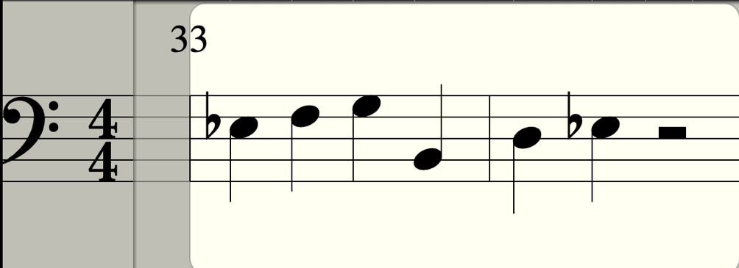
The audios are divided into 2 difficulty groups according to: (1) Tonality of the melody (For example, in Fig. 1, the melody has no obvious tonal center and has some degree of chromaticism.) (2) Salience of the pitch change (In Fig. 2, the changed pitch only differs by a half step, so it is less detectable.) More atonal the melody and less salient the pitch change, more difficult the task is. Audios of the difficult group count 2 marks each, and audios of the easy group count 1 mark each.
Fig. 1. Melody with chromaticism and large leap

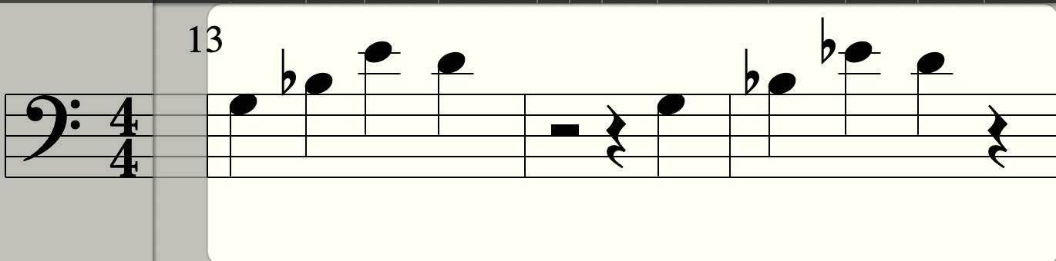
Fig. 2. Melody with only one note shifted by a half step
Rhythm. Similarly, participants listened to 10 audios that each included two versions of a short rhythmic idea (length=4 beats) played by Hi-Hat Closed, Snare Rimshot and Kick, the three most frequently used percussion in a drum kit, from the software drum kit “SoCal” with a 1-bar pause in the middle, and they were asked to judge if these two versions were identical. 4 of the audios are played by Hi-Hat only and the other 6 are played by Snare and Kick together. The audios are also divided into 2 difficulty groups according to the accuracy of responses: If accuracy < 80%, the audio is classified as “difficult” and counts 2 marks; otherwise, the audio counts 1 mark.

1.2 Musical pattern learning
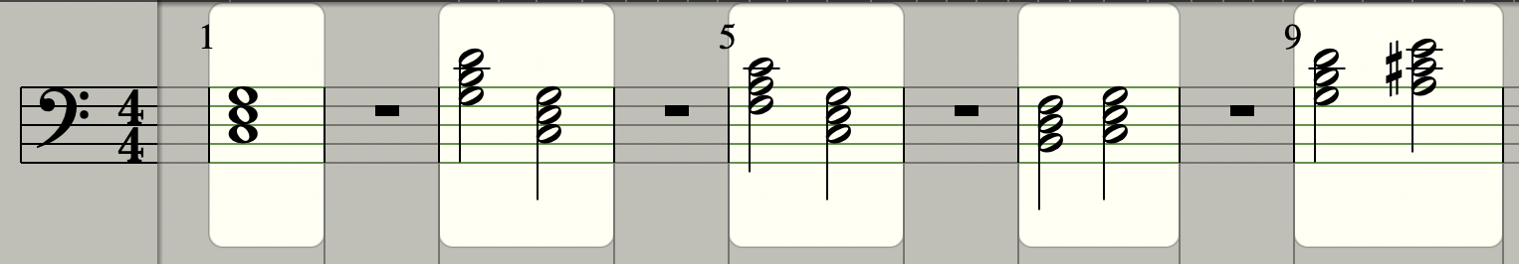
Cadence Learning. Cadences are specific chord progressions in which a musical phrase ends. Participants are presented with an audio of the tonic triad of C major scale and 4 audios of different cadences in the same scale, along with their names: perfect cadence, plagal cadence, leading tone cadence, and interrupted cadence. Audios can be played multiple times for participants to learn and familiarize themselves with the sound of these cadences. Then, participants listened to the tonic triad of F# major scale and were asked to match the 4 audios of cadences in this scale (randomly ordered) to their names. Each match counts 2 marks, and confusing perfect and plagal cadence can gain participants 2 marks in total.
Tonic triad Perfect cadence (V-I) Plagal cadence (IV-I) Leading tone cadence (vii-I) Interrupted cadence (V-vi)
Fig. 3. Types of cadences
Style learning. Many music styles are characterized by their unique drum patterns. Participants are presented with short audio clips (length=4~9 seconds) of 5 music styles’ basic drum patterns along with their names (see Appendix): Trap, Drill, Drum & Bass, Reggaeton and R&B. Then, they are asked to match 5 real samples (length: 5~9 seconds) of these music styles to their names. All the audio in this section can be played multiple times. Each match counts 1 mark.

1.3 Language and music background questionnaire
The questionnaire asks about the participant’s gender (options: male, female, other), age group (options: under 18, 18–25, 26–30, 31–40, 41–50, 51–60, above 60) language background and musical background.

Language background. This section surveyed participant’s native dialect (options: Wu Chinese, Cantonese, Mandarin Chinese, others specified by cities), frequency (on a scale from 1 to 4 with corresponding descriptive statements), fluency (on a scale from 1 to 5 with corresponding descriptive statements), and number of foreign languages spoken (options: 0, 1, 2, 3, >3).

Musical background. This section assessed participants’ duration receiving music training (options: no training, <1 year, 1~3 years, 3~5 years, 5~10 years, >10 years), frequency of music listening (options: daily, 3~4 times weekly, 1~2 times weekly, 1~2 times monthly, almost never), and absolute pitch ability.

